Introduction

To create an online presence, showcase the history, philosophy's cultural significance of Kolhapur talims. concept of "Talim's" came from the wrestling culture of Kolhapur. Shree Shahu Maharaj of Kolhapur has a significant role in this culture. They used to appropriate and give reward to the well established and renowned Wrestler.

As per the time this talim's and mandals changed to the regional and subregional groups and Friends circle. And they adopted the culture of Ganesh Utsar Festival as prime.
The main objective of this change is to get together all around the people and form a good society.

As per the time this talims can mandale adopted the used to arrange, big sport culture and Tournaments in which all around Sport team in Kolhapur used to Participate and Compete with each other.
Talim's are the big highlight of the Kolhapur district. So the main motive of this website is to create Virtual presence of this amazing culture.

Scope

1.Reach and presentation.

- Gather information on Kolhapur Talim History, philosophy, and cultural significance.

- Provide content for the website including text, images and videos.

2.Website design and development.

- Design a Visually appealing and user-friendly website.

- Devolve a static website with the following pages.

Objectives:

1. To provide detailed information about Talim.

2.To create online presence in public.

- To gather all information on one platform.

- To notify all upcoming events.

Tools & Technology.

HTML-
HTML serves as the backbone of the Shahaji Law College Kolhapur website, it providing the structure and content mark-up for web pages. It defines layout of text, images, links, and other media element.

CSS -
CSS is used to style and design the visual presentation of the Shahaji Law College Kolhapur website. It controls the layout, colour scheme, typography and overall aesthetic appeal of web page.

Hardware & Software Requirement

Hardware Requirement :

Hard Disk | :100GB+
RAM | :2.00GB
Processor | :Intel(R)PentiumCPU@1.50GH_{Z}

Software Requirement :
Languages used :HTML & CSS language.
Operating system :Windows 10+ Front-End: HTML, CSS.
Browser :Google chrome, Microsoft Edge.
Application :Visual Studio Code.
System type :32,64 bit +

Home
Feedback
Shivaji Talim
Dilbahar Talim
Rankala talim
Juna Budhvar talim
Practice Club
Patakadil Talim
Balgopal talim
Nathagole Talim
Vetal Talim
Khandoba Talim
Contact us
Talim
3. System Analysis

Data Collection :
The Kolhapur Talim project is an initiative aimed at digitizing and preserving the traditional Indian football of Kolhapur, which originated in the Kolhapur region of Maharashtra, India.

The project involves collecting and documenting various aspects of Kolhapur, including its history, techniques, and cultural significance. To achieve this, the project relies on data collection through various methods, such as:

1. Surveys and interviews: Conducting surveys and interviews with Kolhapur practitioners, trainers, and experts to gather information about the art form's history, techniques, and cultural significance.
2. Observational studies: Conducting observational studies of Kolhapur training sessions and performances to gather data on techniques, movements, and training methods.
3. Documentation of traditional practices: Documenting traditional practices, such as the making of Kolhapur equipment, costumes, and accessories.
4. Collection of archival materials: Collecting and digitizing archival materials, such as photographs, videos, and documents related to Kolhapur Talim history and evolution.
5. Ethnographic research: Conducting ethnographic research to study the cultural and social context of Kolhapur practices and their significance in the lives of practitioners and communities.

System Design:
- Home page
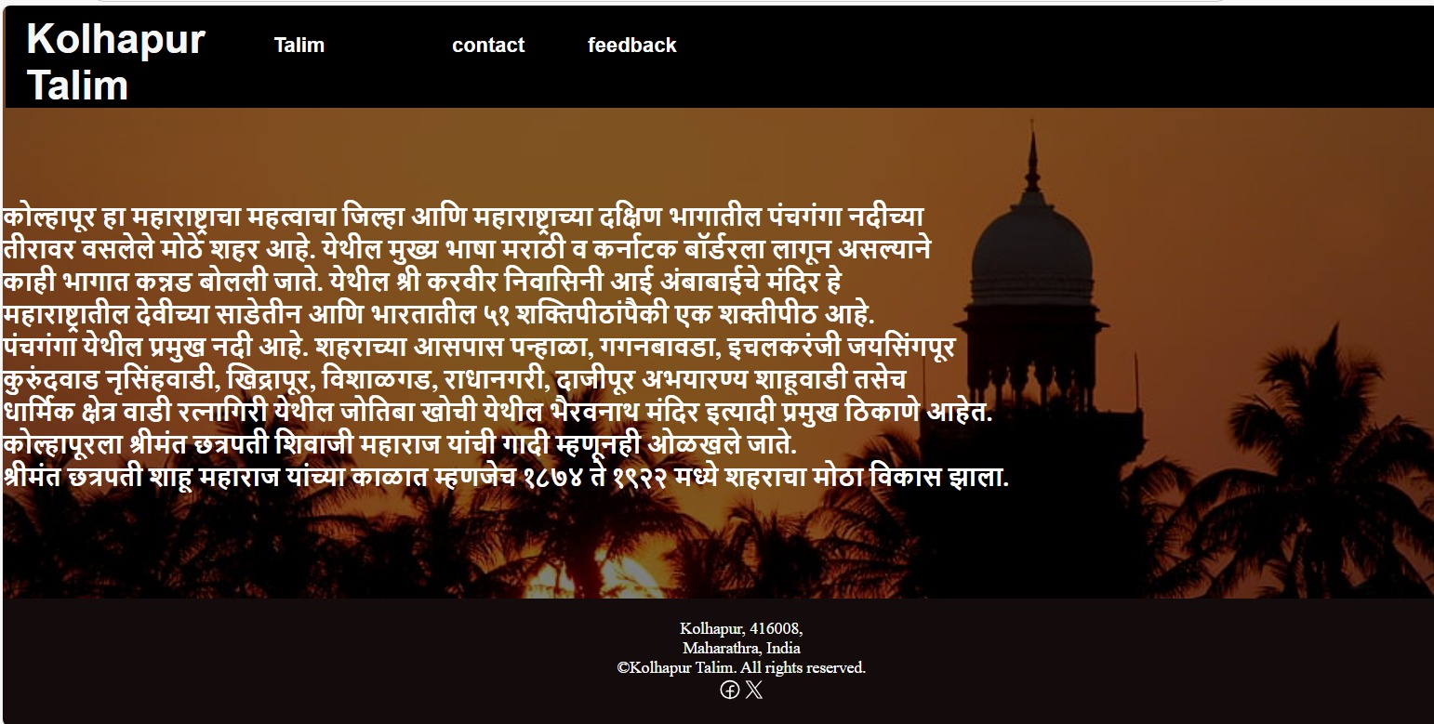

- Talim Page
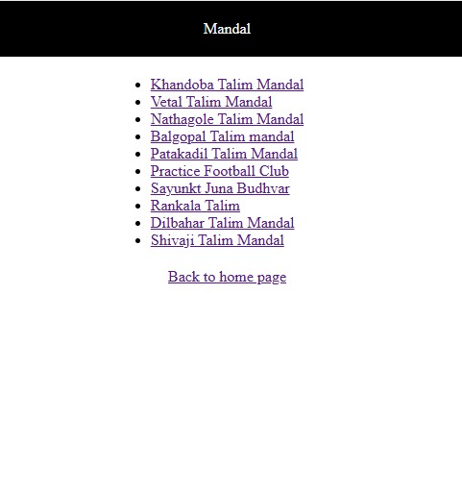

3.Contact page
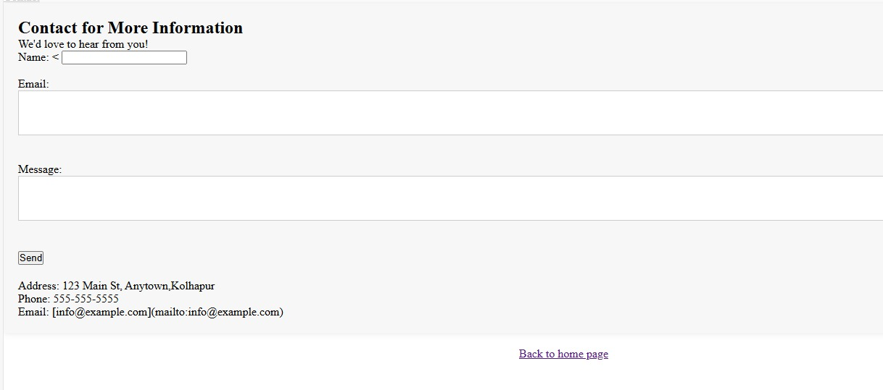

4.Feedback
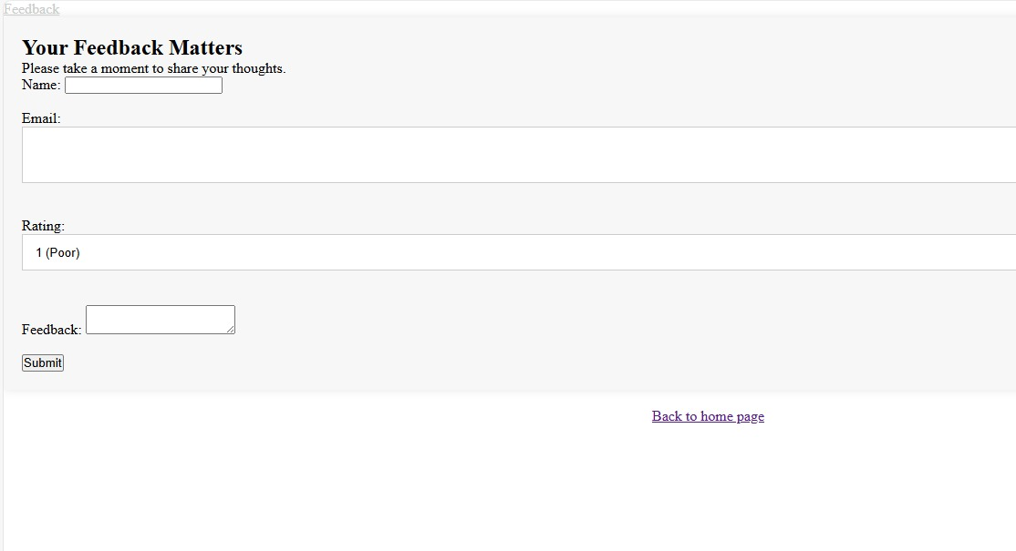

Suggestions :
1. Simple Navigation: Make it easy to find information with clear menus and links.
2. Search Bar: Add a search box so people can quickly find what they need.
3. Event Calendar: Include a calendar for upcoming events and important dates.
4. Contact Info: Provide clear contact details for mandal and friends circles.
5. Attractive Design: Use nice images and a clean layout to make the site look good

Limitation :
Our website plays a crucial role for several reasons. It often gives people their first impression of the Kolhapur, setting the tone for their experience. It also needs to have current and relevant content to keep visitors informed. The website provides essential information, helping visitors to find what we have. By offering a professional and reliable online presence, it helps build trust with prospective. We provides a virtual presence & allowing visitors to explore the Kolhapur from anywhere.

Conclusion :
In conclusion, our website project was a great learning experience and an important step in creating a helpful resource for tourist , and visitors. During this project, we learned about web design, coding, and organizing content. The website acts as a central place for information about friends circles and football in Kolhapur.
Our main goal was to build a user-friendly site that is easy to navigate, informative, and visually attractive. By focusing on clear layouts and easy-to-find information, we aimed to make the online experience better for users, helping them quickly find what they need.

References:
- Google.com
- Respective official members.

